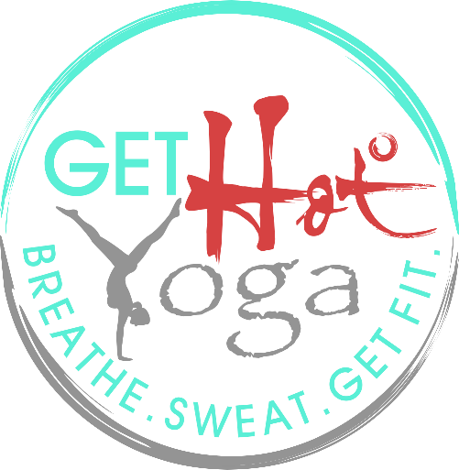

NEW STUDENT CONTACT & LIABILITY RELEASE FORM
Get Hot Yoga, LLC
Wauwatosa, WI 53213

PLEASE PRINT CLEARLY
Student Contact Information
First Name: | Last Name: Middle Initial:
Address:
Phone #: | Birth Date:
Email:
Emergency Contact Name & Number: | Emergency Contact Relationship:
Student Yoga Background
How long have you been practicing YOGA? (circle) | How long have you been practicing HOT YOGA? (circle)
a. Today is my first time | a. Today is my first time
b. 1 year or less | b. 1 year or less
c. More than 1 year | c. More than 1 year
Do you have any injuries or health concerns you would like your instructors to be aware of?

How did you hear about Get Hot Yoga? | (CIRCLE): Flyer, Facebook, Internet, Client Referral, Other  If referred, by who:
Additional comments, questions or concerns?

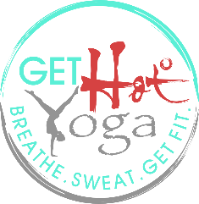
Agreement of Release and Waiver of Liability
WAIVER, RELEASE, INDEMNIFICATION and HOLD HARMLESS AGREEMENT

I _________________________________________(print name) understand that yoga includes physical movements as well as an opportunity for relaxation, stress reduction and relief of muscular tension. I understand I will receive information and instruction; including verbal and physical adjustments about yoga and health. As is the case with any physical activity, the risk of injury, even serious or disabling, is always present and cannot be entirely eliminated. It is my responsibility to consult with a physician prior to my participation in the yoga class.

I represent and warrant that I am physically fit and I have no medical condition that would prevent my full participation in the yoga class. I am aware I may be physically adjusted. I agree to take full responsibility for any risks, loss, claim, injury, damage or liability, known or unknown, which I might incur as a result of participating in the program.

Yoga is not a substitute for medical attention, examination, diagnosis or treatment. Yoga is not recommended and is not safe under certain medical conditions. I affirm that I alone am responsible to decide whether to practice yoga. I knowingly, voluntarily, and expressly agree to accept full responsibility and assume the risk for my use of or participation in any and all classes, activities, apparatus, appliance, facility privilege or service, of any nature, which is owned or operated by Get Hot Yoga, LLC. While engaging in any class or activity operated, organized, arranged or sponsored by Get Hot Yoga, LLC, either on or off their premises, I shall do so at my own risk, and hold Get Hot Yoga, LLC, its employees, representatives and agents, forever harmless from any and all loss, claim, injury, damage, or liability sustained or incurred by me. I specifically agree to indemnify and hold harmless Get Hot Yoga, LLC as to any loss, cost, claim, injury, damage or liability, sustained or incurred by participating in the classes, or through my use of the facilities or equipment of Get Hot Yoga, LLC which is caused by an act or omission, whether negligent, intentional or otherwise, of an employee, representative, or agent of Get Hot Yoga, LLC.

If I do have a physical condition which limits my participation, I take full responsibility for moderating my activity and being aware of my own limitations. I will keep in communication with my teacher and ask questions while listening to instructions carefully. I have told my health professional about taking this program.

I, my heirs, or legal representative forever release, waive, discharge and covenant not to sue Get Hot Yoga, LLC for any injury or death caused by my participation in the yoga class. My signature below constitutes my full acceptance of this waiver.

I have read the release and waiver of liability and fully understand its consent. I voluntarily agree to the terms and conditions stated above and therefore release Get Hot Yoga, LLC (its employees and owners) from any claims, demands and causes of actions arising from my participation in the exercise program.

Signature of Participant _____________________________ Date ___________________

If Participant is Under 18 (must be at least 16 years of age):

As legal guardian of _______________________, I consent to the above listed terms and conditions.
Signature:_______________________________________________ Date: ____________________

WELCOME YOGI! 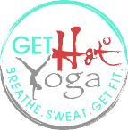
Welcome to Get Hot Yoga! We are so excited to have you join our community! The following information is to help answer questions you may have about Get Hot Yoga and about studio etiquette! Please do not hesitate to reach out to any staff member for additional questions or concerns.
Getting Started:
- Please SIGN IN at the front desk when you arrive to each class.
- ALL LEVELS are welcome. Ease into YOUR practice. We recommend starting with a beginner class or a more gently heated class (85 degrees or less) if you have NEVER practiced HOT power yoga.
- Be sure to INFORM your instructors before class begins of any injuries or conditions. Instructors will be glad to provide appropriate modifications.
- Mats & Towels available to rent at a nominal charge. (We recommend you bring your own). We provide blocks and straps.
- Be sure to try different classes with various instructors to find what suits you best!
- If it is your first HOT yoga class… it may be challenging! And it should be! DO NOT give up. Your body will adjust to the heat after a few classes. You will feel yourself getting STRONGER with each class, and you will GROW rapidly in all aspects of your yoga practice... mind, body & spirit!
- LISTEN TO YOUR BODY. You should always work at your own pace. You are free at ALL times to take resting poses and/or leave the studio for fresh air or water.
- CHANGING ROOMS are provided on site for your convenience.
- Cubbies for shoes/coats/bags are available. It is the risk and liability of each student to leave items in the cubbies during class. The door to Get Hot Yoga’s facilities is locked prior to the start of each class.
Yoga Studio Etiquette/Guidelines:
- Please arrive 10-15 minutes before class to register, use the restrooms, or change into yoga attire (if needed).
- SHOES should be removed immediately as you enter Get Hot Yoga’s facilities.
- Please turn off/silence cell phones before entering Get Hot Yoga’s facilities.
- While in Get Hot Yoga’s facilities, please talk in quiet voices especially if there is another class in session.
- Mat markers are used in the studio to ensure there is a designated spot for each yogi who has signed up. Please place your mat between the markers until the instructor announces that everyone is in class. At that point, feel free to spread out!
Before arriving to class:
- We recommend not eating two hours or more prior to class. (Light snack or fruit ok).
- HYDRATE HYDRATE HYDRATE. It is important to hydrate throughout the day before class as well as AFTER class.
- Please refrain from applying perfumes before class.
- Please wear clean clothes and be sure to wash your towels after each class!
What to Bring:
- Yoga mat, mat towel & sweat towel
- Water bottle
- Wear comfortable, sweat wicking clothing
- Your bare feet (socks ok too, but you will find barefeet works best!)
What to leave at home:
- Your ego
Yoga is for EVERY body! Come with open hearts and open minds. Get Hot Yoga is a JUDGE FREE zone! Get on your mat and just DO YOU. Nobody is watching, nobody is keeping score. We are a community, our goal is to lift each other up, encourage, teach, learn… GROW. Breathe. Sweat. Get Fit!

